**Name:Hemalatha Karumuri**

**Date :8/12/23**

1)Performing subqueries

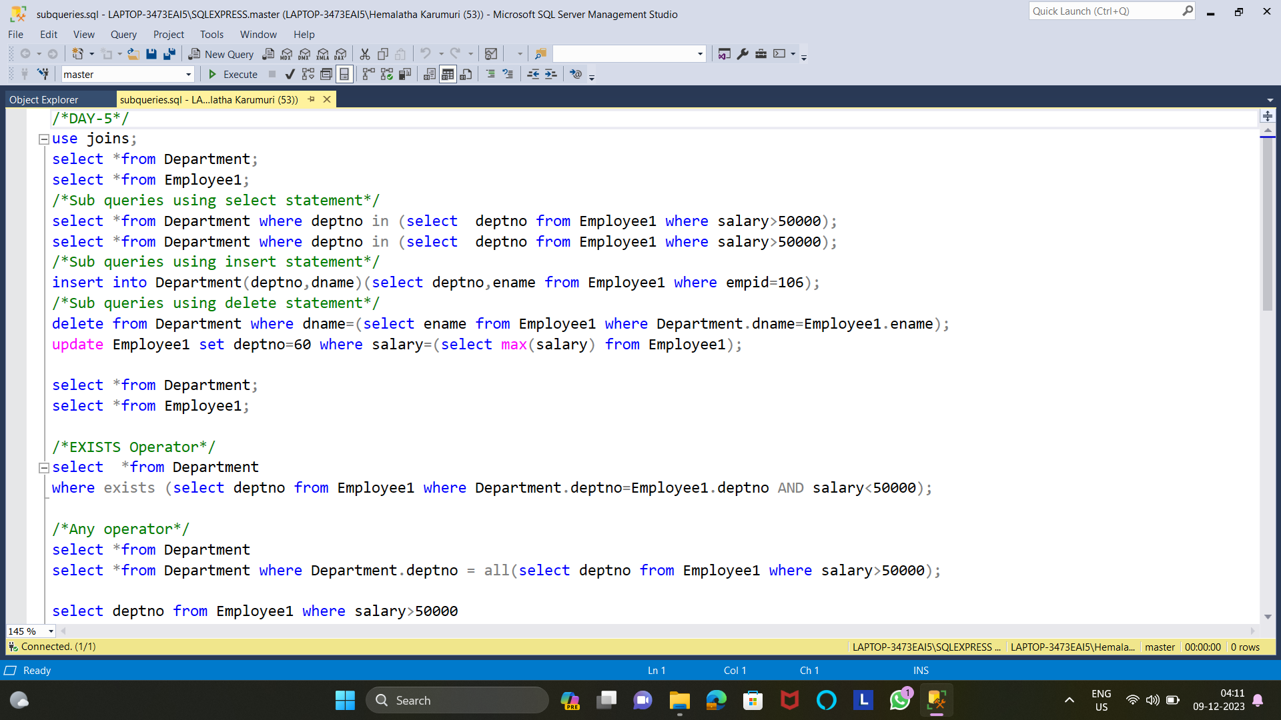

2)using exists,any,all operator in subqueries

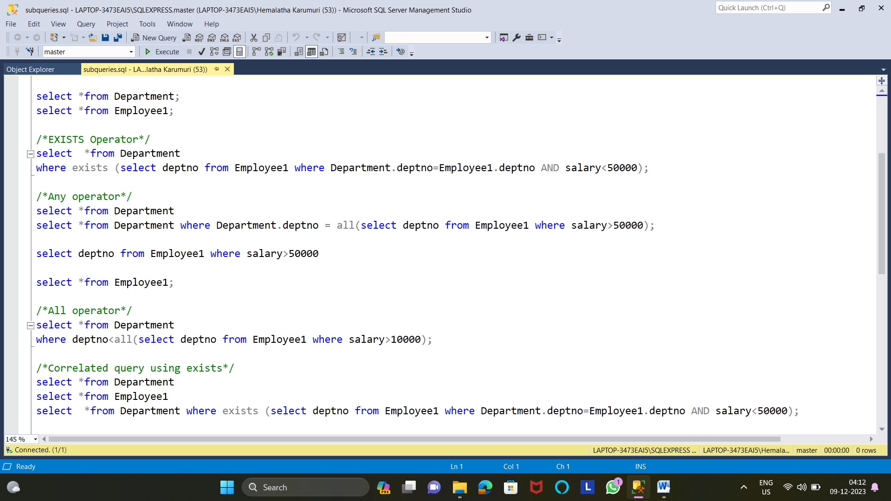

3)correlated subqueries and nested subqueries

